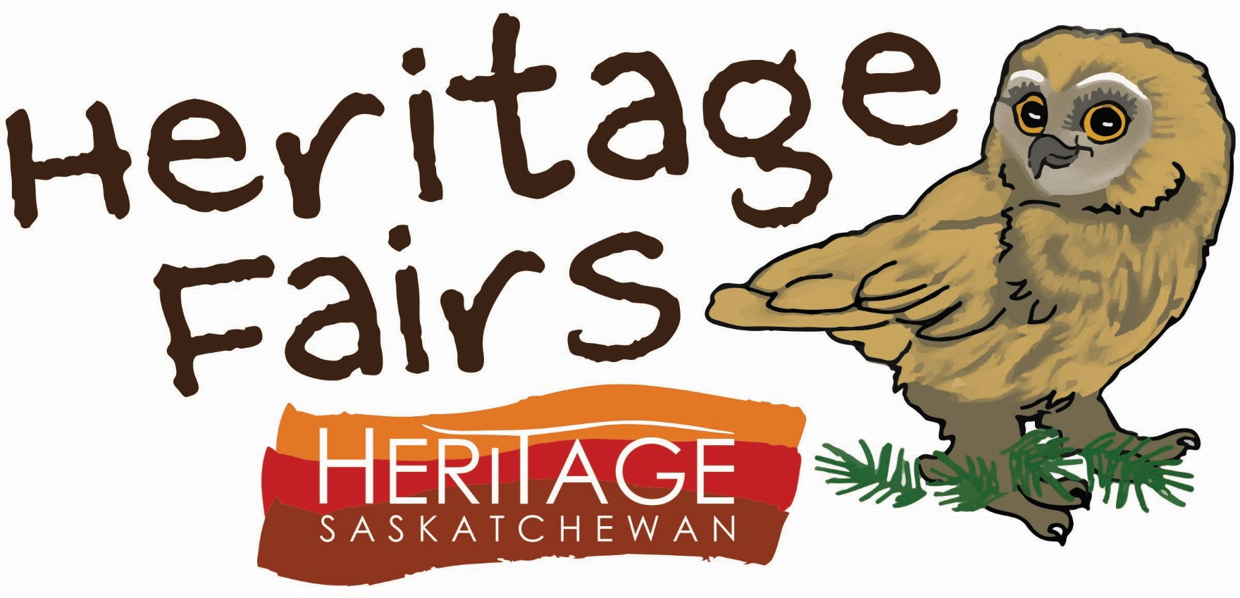
200 – 2020 11th Avenue
Regina, Saskatchewan S4P 0J3
P: (306) 780-9191 F: (306) 780-9190
E: info@heritagesask.ca W: www.heritagesask.ca

Regional Heritage Fair Parent/Guardian Consent Form

Yes, I consent to my child attending the Regional Heritage Fair. (Please circle ‘Yes’ to consent)

(Please circle one of the following: )
Yes, I consent to photos of my child and their project being taken and used for promotion of the Heritage Fair program. I understand that photographs of my child will only identify them by first name and last initial to protect their privacy.
No, I do not consent to photos of my child and their project being taken and used for promotion of the Heritage Fair program.
Any un-circled form will be taken as a lack of consent for photography. Should a parent not consent for their child(ren) to be photographed, these children will be identified to Heritage Saskatchewan’s photographer and measures will be taken to avoid taking photographs of said child(ren). Photos may still be taken of their child(ren)’s project(s).

Parent/Guardian Signature: _____________________________________________

Date: _____________________________________________

Student Information:
School: ______________________________________________________
Community: ______________________________________________________
Teacher: ______________________________________________________
Grade: __________

Student Name: ______________________________________________________
Guardian Name: ______________________________________________________
Guardian E-mail: ______________________________________________________
Home Phone: ______________________________________________________
Mobile Phone: ______________________________________________________
Work Phone: ______________________________________________________

Please list any medical conditions or accessibility concerns:

Please list any allergies or special dietary requirements:



